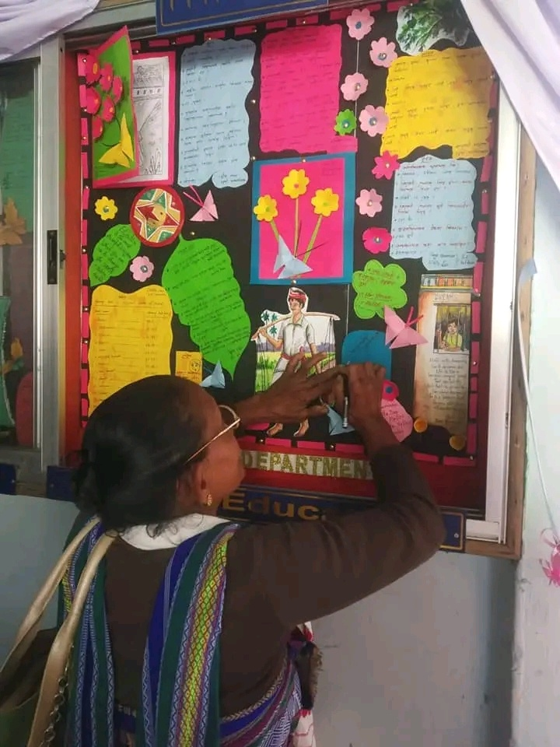

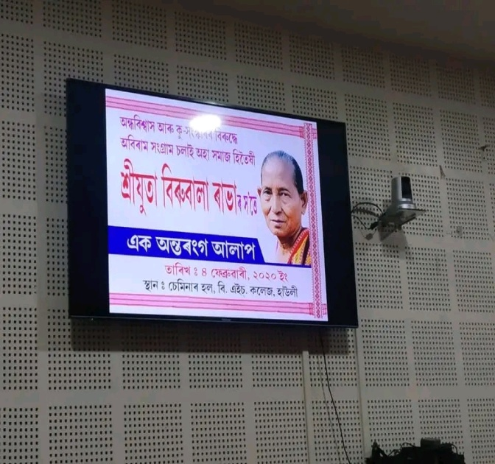
The Departmental Magazine ‘Educare ‘was inaugurated by Padmashree, Dr. Birubala Rabha on 4th February, 2020. On her speech she appreciated the hardwork of the students and advised to do more creative work in future to establish themselves as a responsible citizen in society.

